

**Excel Assignment - 6**

1. What are the various elements of the Excel interface? Describe how they’re used?

Ans: These are following elements are present on Excel interface which have ribbon with various sections:

* File: This contains New, Open, Save etc. function for file.
* Home: This element has different sub-division contain different options for cell, row, and column transformations.
* Insert: This is used to insert/create new table, visualization, and Filter from the existing sheet data.
* Page layout: Used for to Page format.
* Formulas: contain various formulas for finance, text, Date and mathematical etc.
* Data: used to insert different data type and perform sort, filter and grouping.
* Review: used to protect sheet, workbook and add comments and notes.
* View: This contain hide, split and freeze etc which acts to how sheet would to like to set for your interest.
* Automate
* Help

1. Write down the various applications of Excel in the industry.

Ans: The most common uses of Excel in industry are business analysis, managing lists of people, operations management, and performance reporting.

1. 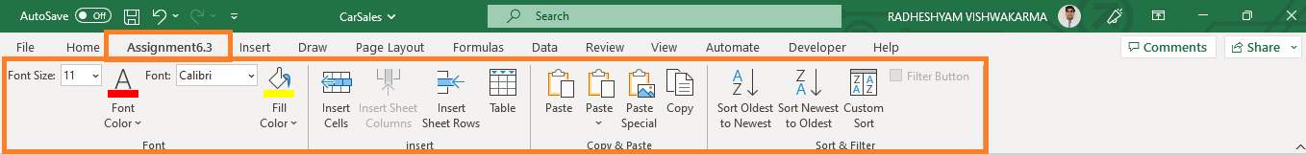On the ribbon, make a new tab. Add some different groups, insert commands in the groups and name them according to their commands added. Copy and paste the screenshot of the steps you followed.
2. Make a list of different shortcut keys that are only connected to formatting with their functions.

Ans: These are different shortcut that are used for formatting:

* CONTROL + B: Applies bold font formatting to headers.
* ALT + H + B + A: Applies borders to the cells.
* ALT + H + B + T: Gives an outline border to the dataset.
* ALT + H + O + W: Autofits column widths
* CONTROL + 1: Opens Format Cells dialog box.

Note: - We can use “Alt” key for performing various action after selecting respective keys.

1. What distinguishes Excel from other analytical tools?

Ans: There are following features and advantages makes Excel different from other Analytical tools:

* It’s easy to get started with Excel.
* The learning resources are very rich.
* You can do a lot of things with Excel: modeling, visualization, reports, dynamic charts, etc.
* It can help you understand the meaning of many operations before further learning other tools (such as Python and R).

1. Create a table and add a custom header and footer to your table.

Ans:

